Naïve Bayes Model
For the next model naïve bayes was selected. As with the previous model, the dataset used is preprocessed from the original dataset. Naïve Bayes is a classification method, which means that the data will need to be transformed in order to use this type of mode. More specifically, the variables currently stored as characters in the data set will need to be converted to factors. The first step in this process is then converting these chr into factors. After this initial conversion takes place an additional conversion is made, whereby all factors are then converted to numeric variables. Next the response variable is removed from the data and placed in a variable in named response, in this instance the gname or group name is the variable of interest. Next, the predictors are then placed in their own variable named accordingly. Normalization must then be applied to the data set before PCA can be performed. After normalizing the dataset, Principal Component Analysis was used to determine the variables of interest.
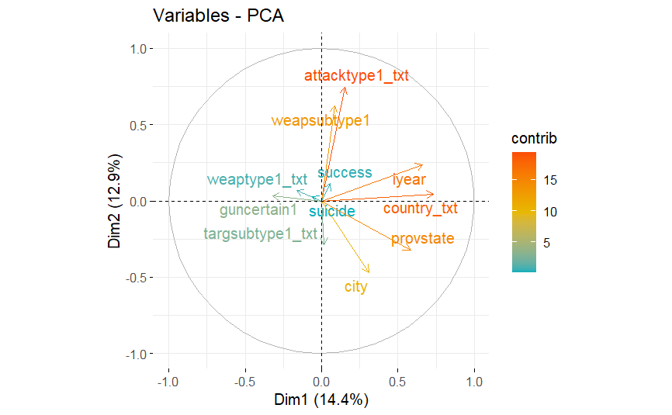
Figure 1.1
Figure 1.1 displays the PCA variables plot, where according to the plot the first component explains 14.4% of the variation in the data, and the second component explains about 12.9% of the variation in the data. The plot also indicates which variables are of the most interest via color coding of the text in the plot. Here it can be observed that the attacktype, country, provstate, and iyear are the most significant contributors to the explanation of the variance in the data. Additional visualizations of the component selection can be found by looking at the scree plot and barplot of the component selection.
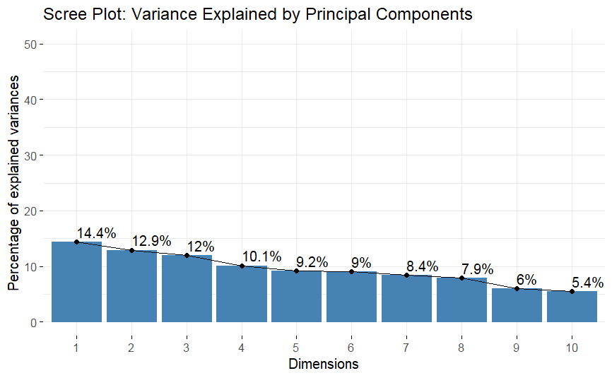
Figure 1.2
Figure 1.2 displays the scree plot for the principal component selection. The scree plot reflects the findings from figure 1.1, where component 1 is shown to explain 14.4% of the variation in the data. Component 2 likewise, is shown to explain 12.9% of the variation as shown in figure 1.1. However, the additional components can be seen here, where component 3 also has a decent amount of percentage. Components 4,5 and 6 show a decent amount of percentage as well, with the real drop coming at component 9. As such, models with up to 8 components should have the highest explanation of the variance in the model, and as a result, should perform the best in terms of accuracy of predictions by the model.

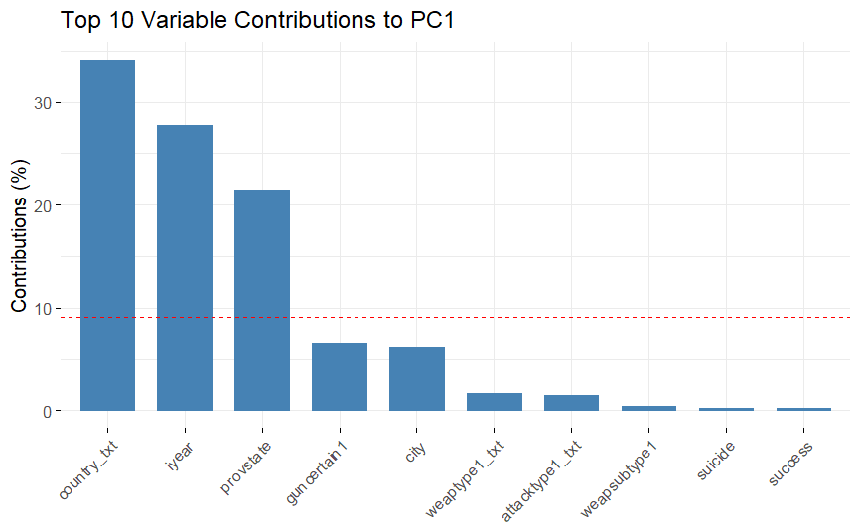
Figure 1.3
Figure 1.3 displays the barplot produced by examining the top contributing variables to component 1. Here it can be observed that country of attack played the most significant contributing role to determining the group name, which in itself not very surprising. Year is next, which also makes some logical sense as demographics and political attitudes change over time, so a group that may be highly active for one decade may come into power, may dissolve, disband, or fade/combine into other factions to make a new group. Gun certain is slightly more interesting in terms of unique unexpected outcomes. This indicates that certain groups operate with a preference for certain types of attacks, those who use guns or do not use guns can provide a good indication of who is behind a unclaimed attack. This value is of course below the cutoff for contribution to the component as indicated by the red line running horizontally across the plot.
Model 1: PCA=Default Value | Accuracy: 61.20%
Model 2: PCA=11 | Accuracy: 64.18%
Model 3: PCA=6 | Accuracy: 61.20%
Model 4: PCA=8 | Accuracy: 66.17%
Model 5: PCA= 4 | Accuracy: 61.70%
Figure 1.4
Figure 1.4 shows a table with the results of each of the Naïve Bayes models run. As can be seen in the table, the performance is fairly poor across the board, with the best performance found by using 8 components netting an accuracy of 66.17%. This indicates that Naïve Bayes may not be the best method for trying to obtain predictions with this dataset. Additional performance may be found by additional parameter tuning, but for now, the next model will be run to see if better performance can be found elsewhere.

Support Vector Machine Model
The next model selected is the Support Vector Machine model. This model, like the naïve bayes model used before it, will require some additional pre-processing of the data before it can be used. It should be noted that the PCA selection of 11 was used for the creation of the training and test data sets used in the SVM model. This was done to ensure that the largest number of predictor variables was used with the dataset, however, this may have also caused performance issues with the model. As such, given more time, the model would have been run a second time with independent pre processing performed on the data before being used with SVM. This may have resulted in better performance for the model. Once the data was split the SVM model was run on the data as is to establish a baseline of performance. The baseline performance of the model was 65.90%. This is roughly the same performance that one could expect from using the naïve bayes model. In order to gain more accuracy, the dataset was binarized and then the SVM model was reapplied. Unfortunately, this did not help performance, in fact, it degraded the performance of the model substantially. The accuracy of the model after binarizing the dataset dropped to 45.13%. Repeated model creation using various kernels did little to improve the performance of the model, where sigmoid and radial kernels performed as poorly as the default method. In hindsight, polynomial kernel should have been used on the non binarized data to establish more of a baseline for this method. Due to the poor performance of the SVM with this data, this model can not be recommended, that is, without further considerations being addressed mentioned at the beginning of this section.

Neural Network Model
As a last ditch hail mary to obtain a model that gave reasonable performance, a neural network model was quickly cobbled together. However, due to the rapid nature of the deployment of this model, pre-processing errors and incorrect model application may be present. As such, this section should be regarded only as a proof of concept and not as a conclusive statement about the effectiveness of Neural Networks with this type of data. With more time additional pre-processing and model creation steps would have been taken in order to try and obtain optimal performance from the model. The first issue arose when trying to use variables that were factors in the dataset. After several different attempted solutions were applied to no avail, the data set was stripped of the factor variables and only left with the numeric variables with the exception of the predictor. The dataset was then normalized with only the numeric variables present, and then split into training and test datasets.

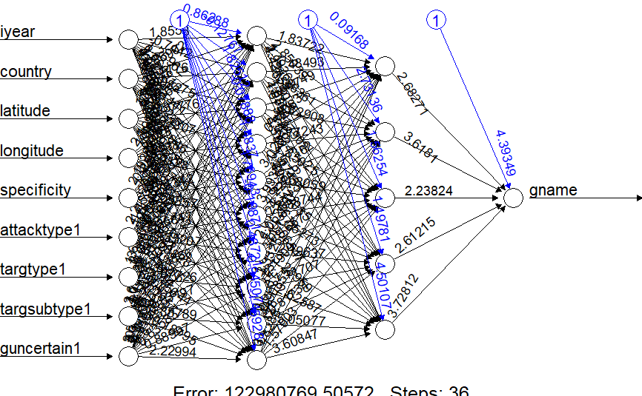
Figure 1.5
Figure 1.5 shows the neural network plot. Once more it should be noted that the variables listed are only numeric variables as all other variables were removed. Obtaining this output resulted in a short lived celebration as immediately problems were encountered in trying to obtain the accuracy of the model. Unfortunately, despite obtaining a model, issues were present in trying to convert the factor response back to its original state for comparison. This is most assuredly operator error, and as a result of this operator error the results of the Neural Network are inconclusive. As a result the model is considered void for this analysis.

